

Mathematics Specialist Unit 1

Test 4

Trigonometry

Name: ______________________ Total Marks:__________

Task type: Response

Time allowed for this task: 60 minutes, in-class, under test conditions
Section One: Calculator-free 30 minutes ( 30marks)
Section Two: Calculator-assumed 30minutes ( 30marks)

Materials required: Calculator with CAS capability (to be provided by the student)

Standard items: Pens (blue/black preferred), pencils (including coloured), sharpener, correction fluid/tape, eraser, ruler, highlighters

Special items: Drawing instruments, templates, notes on one unfolded sheet of
A4 paper, and up to three calculators approved for use in the WACE examinations
Formula sheet

Marks available: 60 marks

Task weighting: 7%

Section One : Calculator Free 30 Marks
Time Allowed 30 minutes

Question 1
[7 marks]
- Solve for $x$ in ${3sec}^{2}{x=}4$ for $0≤x≤2π$
[3 marks]

- Find all the solutions (in radians) for x in $2\sin\left(x-\frac{π}{2}\right)=-1$
[4 marks]

Question 2
[4 marks]
Find $θ$ in $2\sin^{2}{θ+\cos{θ=2}} for 0≤x≤2π$

Question 3
[6 marks]
On the grids below sketch the following graphs of
- $y=3\cos{(2x)}$
[3 marks]

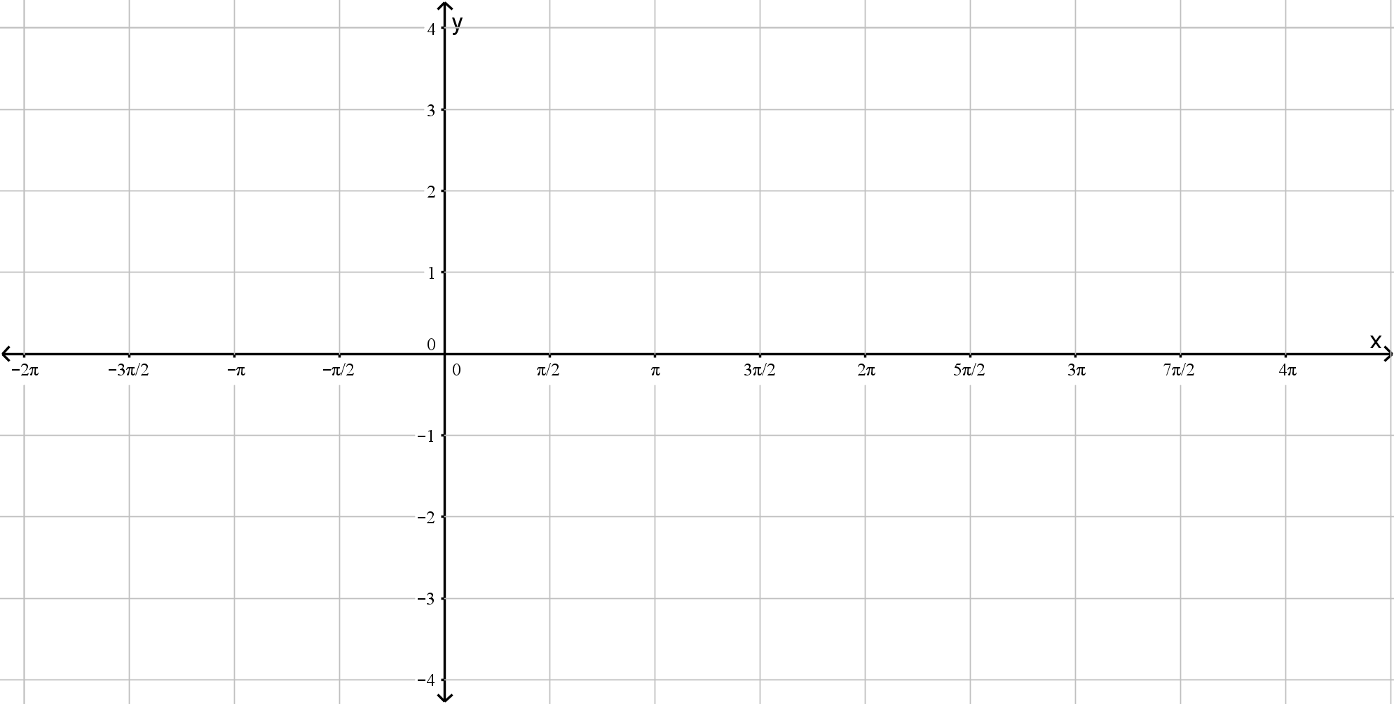

- $y=cosec({x)-1}$
[3 marks]



Question 4
[4 marks]
Evaluate:

- $cos75°cos15°.$
[2 marks]

- $\sin{\frac{11π}{12}}\sin{\frac{π}{12}}$

[2 marks]

Question 5
[9 marks]
Prove that, for $\cos{x≠0}$,
$\sin{2x}-\tan{x}≡\tan{x\cos{2x}}$

[5 marks]

Hence, or otherwise, solve the equation

$$\sin{2x}-\tan{x}≡\sqrt{3}\cos{2x}$$

For $0≤x≤180°$

[4 marks]

Section Two : Calculator Assumed 30 Marks
Time Allowed 30 minutes Name:_______________________

Question 6
[9 marks]

Given that
$$\sin{A=\frac{3}{5}} and \tan{B=-\frac{1}{2}, where A and B are obtuse,}$$

use appropriate trigonometric identities to find the exact value of:

- $\cos{A}$
[1 mark]

- $\tan{A}$
[1 mark]

- $\sin{2A}$
[2 marks]

- $\tan{(A+B)}$
[2 marks]

- $\cos{(A+B)}$
[3 marks]

Question 7
[9 marks]

- Express $2\sin{x}-3\cos{x}$ in the form $R\sin\left(x-α\right)$ where $R>0$and $0<α<90°$. Hence find the exact value or $R$ and $α$ to two decimal places.

[3 marks]

- Show that the equation $\operatorname{cosec}{x}+3\cot{x}=2$ can be written in the form $2\sin{x}-3\cos{x=1}$

[3 marks]

- Solve the equation $\operatorname{cosec}{x}+3\cot{x}=2$ for $0<x<360°$ giving your answers to one decimal place.

[3 marks]

Question 8
[12 marks]
Prove the following identities

- $\sec^{2}{θ}=\sec{θ}\operatorname{cosec}{θ}\tan{θ}$
[3 marks]

- $\sin\left(3θ\right)=3\sin{θ-4\sin^{3}{θ}}$
[4 marks]

- $2\cot\left(2θ\right)+\tan{θ}≡\cot{θ}$

[5 marks]

